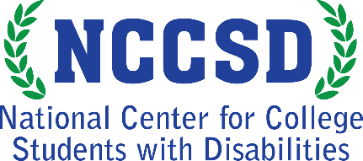
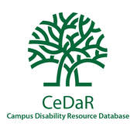
Infographic: Campus Accommodations most commonly provided for college students with disabilities
Learn more at CeDaRdatabase.org
Campus representatives from 740 colleges and universities responded to this question:
“Within the last three years, how common has it been for your institution and/or
disability services provider to provide or approve the following accommodations?”
Top 5 Most Commonly Provided Accommodations
92% Test accommodations
60% 24/7 Alternative formats (e.g. e-text, large print)
60% Accommodations for online courses
54% Assistive technology (e.g. screen readers, voice input)
48% Accommodations in residence halls

Additional Accommodations (graph)
Emotional support animals 39%
Priority registration 37%
Readers 32%
Sign language interpreters 25%
Dietary accommodations 24%
Medical leave 245
Scribes 23%
Reduced courseload 21%
CART or C-Print 19%
Accommodations for internships, et al 15%
Course substitutions 9%
Accommodations for study abroad 9%

The National Center for College Students with Disabilities (NCCSD) is funded through a four-year grant from the Office of Postsecondary Education, U.S. Department of Education (P116D150005), administered through the Office of Postsecondary Education. This project was developed in partnership with the Institute for Community Inclusion (ICI) at the University of Massachusetts Boston. Opinions expressed on this page or associated content may not be the opinions of NCCSD, AHEAD or the U.S. Department of Education. Questions, concerns or requests about accessibility should be sent to nccsd@ahead.org

