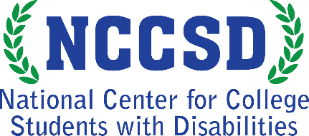
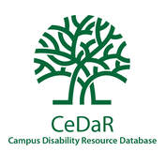
Infographic: Policies & Procedures for Students with Disabilities
621 college and university representatives identified the policies and procedures related to students with disabilities currently in place on their campuses. The top 7 policies and procedures are below.
Learn more at CeDaRdatabase.org
95% Formal grievance policies and procedures for students with complaints about campus disability access
93% Standardized or recommended syllabus statements regarding disability accommodations
86% Grievance procedures for students with complaints about the disability resource office
67% Emergency evacuation procedures include plans for students with disabilities
60% Institutional policy requiring that all online materials are accessible to students with disabilities (compliant with Section 508)
43% Centralized funding for disability accommodations at events
43% Faculty diversity hiring initiatives include efforts to recruit and retain faculty with disabilities
*38% also have a provision of interpreters and Communication Access Realtime Translation (CART) for all major events and 36% also provide opportunities for students with disabilities and without a high school diploma to take courses.

The National Center for College Students with Disabilities (NCCSD) is funded through a four-year grant from the Office of Postsecondary Education, U.S. Department of Education (P116D150005), administered through the Office of Postsecondary Education. This project was developed in partnership with the Institute for Community Inclusion (ICI) at the University of Massachusetts Boston. Opinions expressed on this page or associated content may not be the opinions of NCCSD, AHEAD or the U.S. Department of Education. Questions, concerns or requests about accessibility should be sent to nccsd@ahead.org

