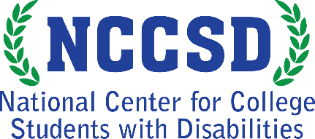
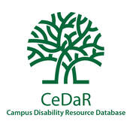
Infographic: Counseling and Psychological Services
Close to 600 campus representatives provided information about the counseling
and psychological services provided at their institutions.
This infographic illustrates the top six services provided to students.
Learn more at CeDaRdatabase.org
82% Short-Term Counseling (e.g. 10 session limit)
72% 24/7 Mental health hotline or Crisis Line
47% Support Groups
45% Campus-Based Chaplains
36% Long-Term Counseling
33% Online Mental Health Services, Trainings, or Supports

The National Center for College Students with Disabilities (NCCSD) is funded through a four-year grant from the Office of Postsecondary Education, U.S. Department of Education (P116D150005), administered through the Office of Postsecondary Education. This project was developed in partnership with the Institute for Community Inclusion (ICI) at the University of Massachusetts Boston. Opinions expressed on this page or associated content may not be the opinions of NCCSD, AHEAD or the U.S. Department of Education. Questions, concerns or requests about accessibility should be sent to nccsd@ahead.org

